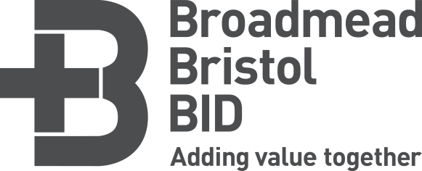

Summary of notes from BID marketing meeting
21st October 2015

In attendance: Aaron Edmondson, Sketchers Rae Stanton, Lush
Andy Hills, Antics Rob Bailey, Marks & Spencer
Cameron Lang, The Galleries Slawek Walak, The Change Group
Cara Collins, Bhs Jenny Ford, Build-A-Bear Workshop
Caroline Tiernan-Locke, Consol Sian Salmons, Debenhams
Kelly Haywood, Taking Shape Sophie Neveu, Destination Bristol
Ken Jessney, Santander Viv Kennedy, Destination Bristol
Kit Bellamy, Hallmark

Chair: Jo Hawkins, Broadmead BID manager

- BID marketing update
This included:
- Cheers Drive! Campaign
- Shaun in the City
- BID Christmas marketing campaigns
- Social media opportunities
- Future events
To see the full presentation, please see: http://www.broadmeadbristolbid.co.uk/your-bid-your-say/downloads/

- The Galleries update
- Freshers’ fairs – the 2 fairs hosted in The Galleries in September had been very positive.
- Halloween – the large pop up shop on the ground floor has proved very successful
- Black Friday, 27th November – The Galleries will be open from 8am - 8pm; 8pm Christmas opening on 27th November.
- Christmas advertising is currently being finalised and will include a radio campaign with Breeze as well as press and bus side advertising.
- Santa’s Grotto will open on 6th November, coinciding with BSQ Christmas lights switch-on event. The Grotto will be open every weekend in November and every day in December until Christmas Eve.
- Social media – Since January 2015, the number of ‘likes’ on Facebook has doubled and Twitter followers have tripled, thanks to the recent appointment of The Galleries’ new marketing agency.

- Healthy High Streets
- Rob Bailey gave an introduction and update on the positive progress of this campaign.
- Greggs and EE have now joined the current partner organisations M&S, Boots and Santander.
- Rob will continue to host regular informal meetings (Wake Up & Smell The Coffee!) in the M&S café. These meetings are a great opportunity for sharing success and building networks. All are welcome.
- Cleansing & maintenance update
- The cleansing team is working hard to keep on top of the cleansing and graffiti issues in Broadmead. If you are aware of any problems, please contact the BID team.
- Empty store The Money Shop in Nelson Street has been a target for graffiti recently –
Action: Jo to look at this area and organise the cleansing of this unit.

- How can we help?
- The BID team is happy to promote your offers, events and news via the Bristol Shopping Quarter website and via our social media platforms. Please email viv.kennedy@destinationbristol.co.uk with details and images.

- AOB
- All agreed 10am is a good time to host our BID marketing meetings; the days in 2016 will alternate to give all retailers the opportunity to attend.
- A group brainstorming session will be organised at our next BID marketing meeting; this will be a chance for retailers to think about how to maximise BID opportunities for their benefit.
- The positive results of late night trading was discussed. Retailers were encouraged to consider opening later in order to benefit.
- Andy Hills had a query re: MetroBus works during the Christmas period.
Action: Jo to get back to Andy Hills with more info.

Many thanks for attending this meeting. Please contact Jo or Sophie with any queries or with any additional feedback:
jo.hawkins@destinationbristol.co.uk / sophie.neveu@destinationbristol.co.uk
Next meeting:
Date and venue to be confirmed

